COMPLETE CI/CD PROJECT

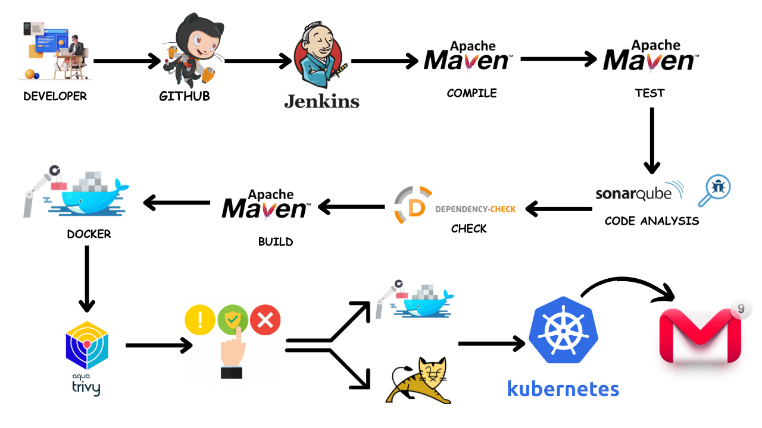
I will be deploying a Pet Clinic Java Based Application. This is an everyday use case scenario used by several organizations. i will be using Jenkins as a CICD tool and deploying our application on Tomcat Server.
I will be deploying our application in two ways, using Docker Container and other is using Tomcat Server.And finally we will deploy it kubernetes Also.

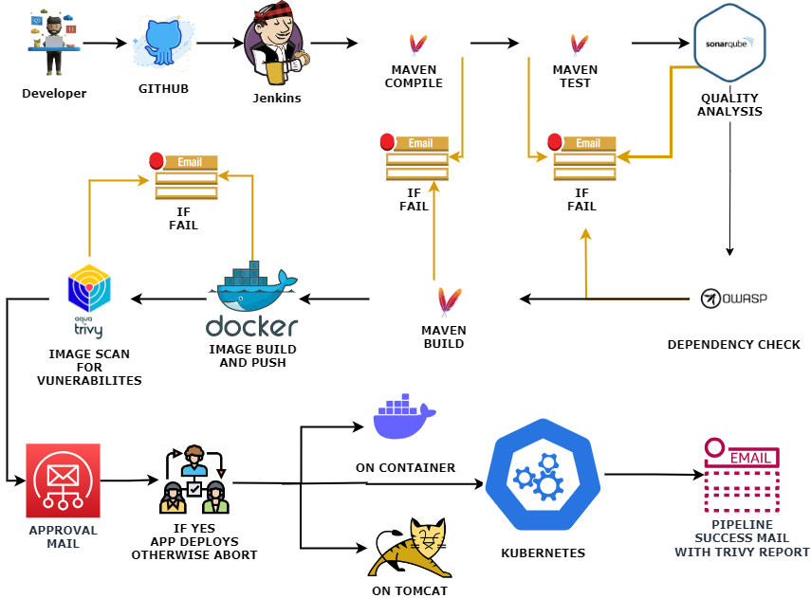

Steps
Step 1 : Create an Ubuntu T2 Large Instance
Step 2: Install Jenkins, Docker and Trivy. Create a Sonarqube Container using Docker.
Step 3: Install Plugins like JDK, Sonarqube Scanner, Maven, OWASP Dependency Check
Step 4: Create a Pipeline Project in Jenkins using Declarative Pipeline
Step 5: Install OWASP Dependency Check Plugins
Step 6: Docker Image Build and Push
Step 7: Deploy image using Docker
Step 8: Install Tomcat on Port 8083 and finally deploy on Apache Tomcat using groovy pipeline script mentioned
Step 9: Access the Real World Application
Step 10: Terminate the AWS EC2 Instance
Step 1 — Launch an AWS T2 Large Instance. Use the image as Ubuntu. You can create a new key pair or use an existing one. Enable HTTP and HTTPS settings in the Security Group.
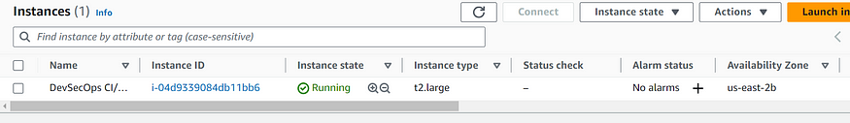
Step 2: Install Jenkins, Docker and Trivy
To Install Jenkins
Connect to your console, and enter these commands to Install Jenkins
sudo apt-get update
curl -fsSL https://pkg.jenkins.io/debian-stable/jenkins.io-2023.key | sudo tee \
/usr/share/keyrings/jenkins-keyring.asc >/dev/null
echo deb [signed-by=/usr/share/keyrings/jenkins-keyring.asc] \
https://pkg.jenkins.io/debian-stable binary/ | sudo tee \
/etc/apt/sources.list.d/jenkins.list >/dev/null
sudo apt update
sudo apt install openjdk-17-jdk
sudo apt install openjdk-17-jre
sudo systemctl enable jenkins
sudo systemctl start jenkins
sudo systemctl status jenkins
sudo cat /var/lib/jenkins/secrets/initialAdminPassword
Once Jenkins is installed, you will need to go to your AWS EC2 Security Group and open Inbound Port 8080, since Jenkins works on Port 8080.
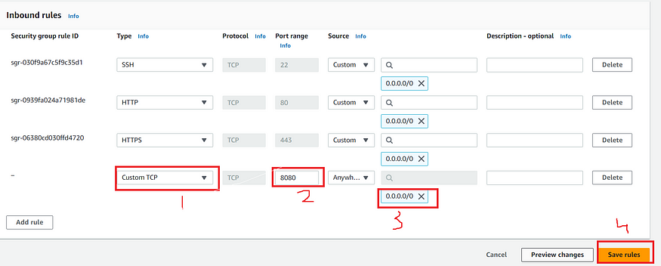
Now, grab your Public IP Address
<EC2 Public IP Address:8080>
sudo cat /var/lib/jenkins/secrets/initialAdminPassword
Unlock Jenkins using an administrative password and install the required plugins.
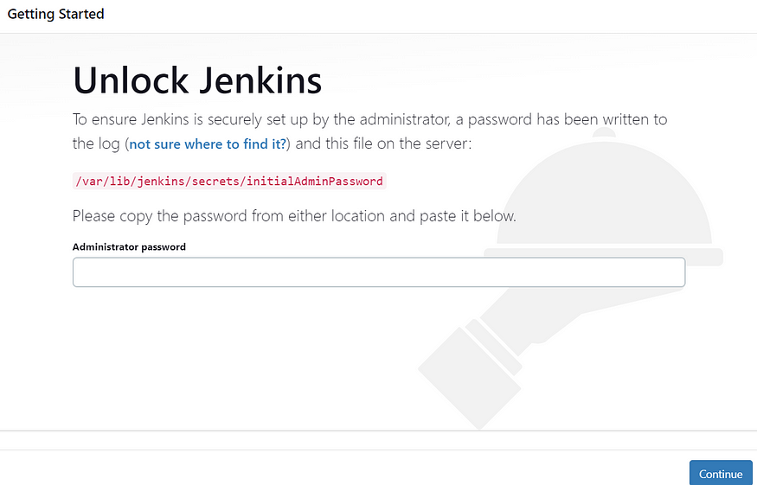
Jenkins will now get installed and install all the libraries.
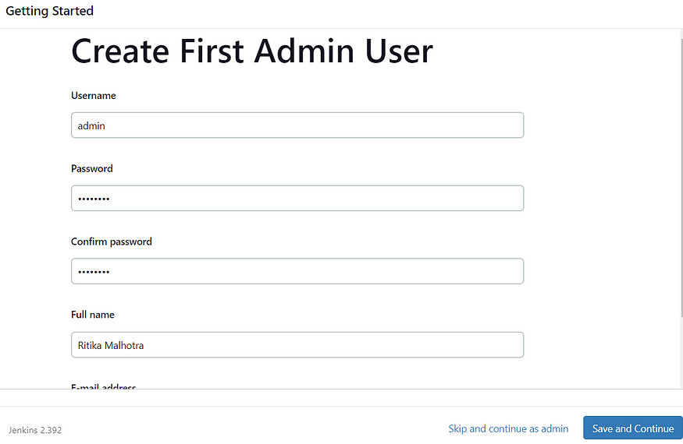
Jenkins Getting Started Screen
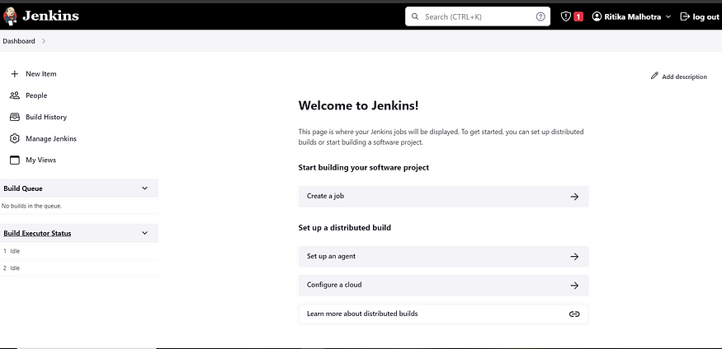
2B — Install Docker
sudo apt-getupdate
sudo apt-get install docker.io -y
sudo usermod -aG docker $USER
sudo chmod 777 /var/run/docker.sock
sudo docker ps
After the docker installation, we create a sonarqube container (Remember added 9000 port in the security group)
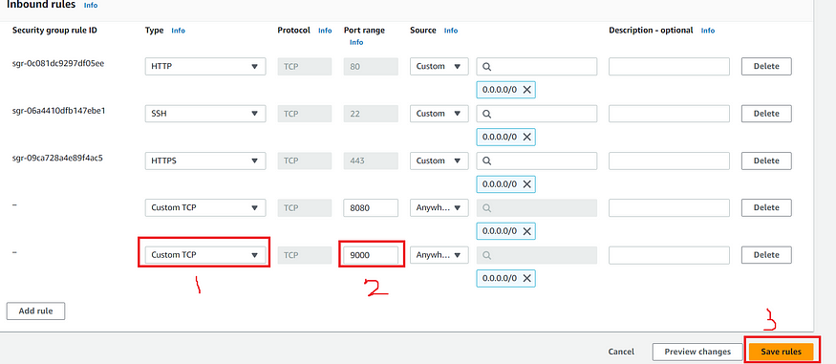
docker run -d --name sonar -p9000:9000sonarqube:lts-community
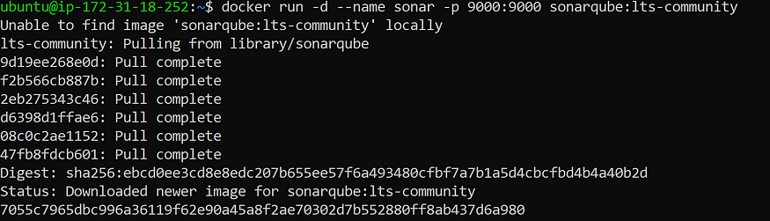
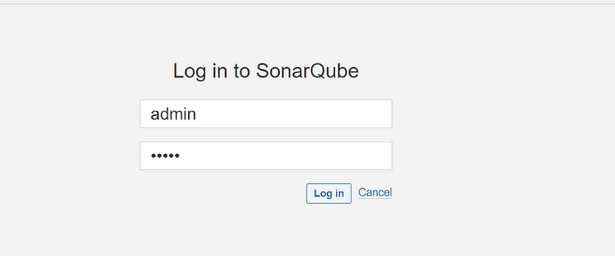
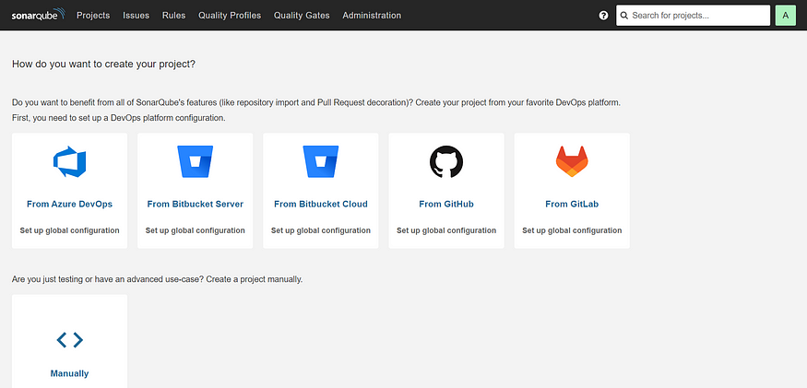
Install Trivy
sudo apt-get install wget apt-transport-https gnupg lsb-release -y
wget -qO - https://aquasecurity.github.io/trivy-repo/deb/public.key | gpg --dearmor | sudo tee /usr/share/keyrings/trivy.gpg > /dev/null
echo"deb [signed-by=/usr/share/keyrings/trivy.gpg] https://aquasecurity.github.io/trivy-repo/deb $(lsb_release -sc) main" | sudo tee -a /etc/apt/sources.list.d/trivy.list
sudo apt-get update
sudo apt-get install trivy -y
Next, we will login to Jenkins and start to configure our Pipeline in Jenkins
Step 3: Install Plugins like JDK, Sonarqube Scanner, Maven, OWASP Dependency Check
Install Plugin
Goto Manage Jenkins →Plugins → Available Plugins →
Install below plugins
1 → Eclipse Temurin Installer (Install without restart)
2 → SonarQube Scanner (Install without restart)
Configure Java and Maven in Global Tool Configuration
Goto Manage Jenkins → Tools → Install JDK and Maven3 → Click on Apply and Save
Create a Job
Label it as Real-World CI-CD, click on Pipeline and Ok.
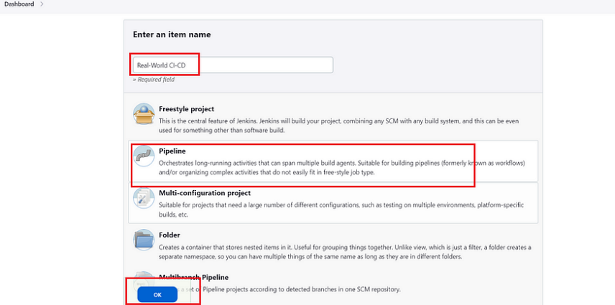
Enter this in Pipeline Script,
pipeline {
agent any
tools{
jdk 'jdk17'
maven 'maven3'
}
stages{
stage("Git Checkout"){
steps{
git branch: 'main', changelog: false, poll: false, url: 'https://github.com/Milky19/Petclinic.git'
}
}
stage("Compile"){
steps{
sh "mvn clean compile"
}
}
stage("Test Cases"){
steps{
sh "mvn test"
}
}
}
}
The stage view would look like this,
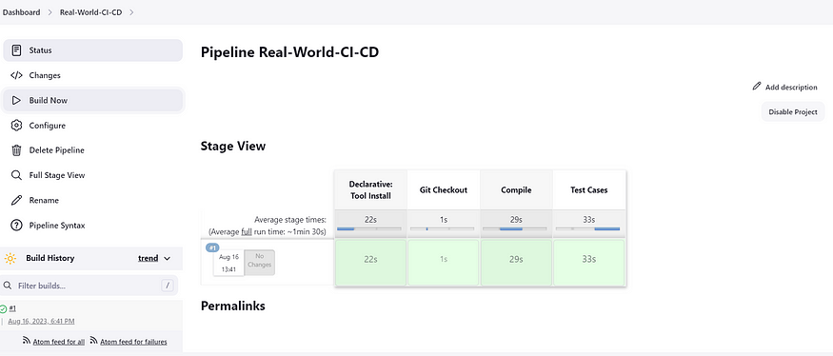
Step 4: Configure Sonar Server in Manage Jenkins
Grab the Public IP Address of your EC2 Instance, Sonarqube works on Port 9000 , sp <Public IP>:9000. Goto your Sonarqube Server. Click on Administration → Security → Users → Click on Tokens and Update Token → Give it a name → and click on Generate Token
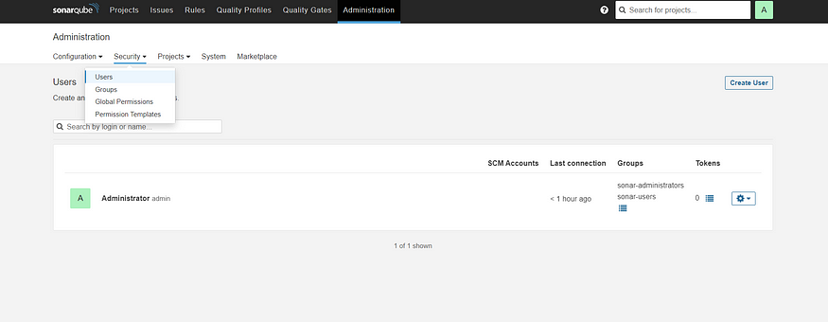
Click on Update Token
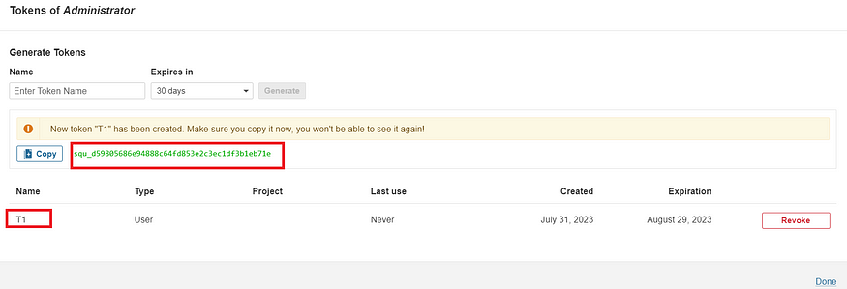
Copy this Token
Goto Dashboard → Manage Jenkins → Credentials → Add Secret Text. It should look like this
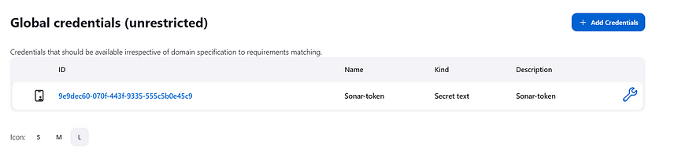
Now, goto Dashboard → Manage Jenkins → Configure System
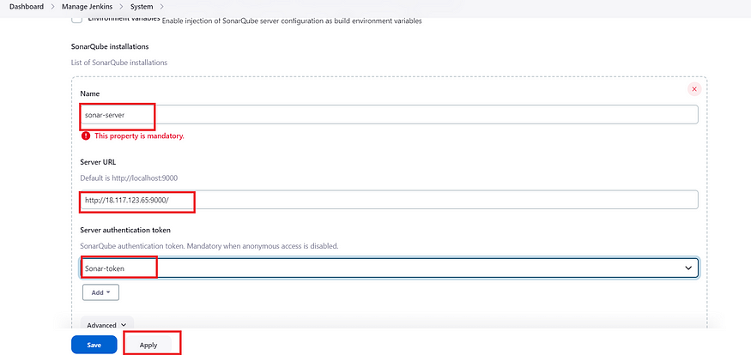
Click on Apply and Save
Configure System option is used in Jenkins to configure different server
Global Tool Configuration is used to configure different tools that we install using Plugins
We will install sonar-scanner in tools.
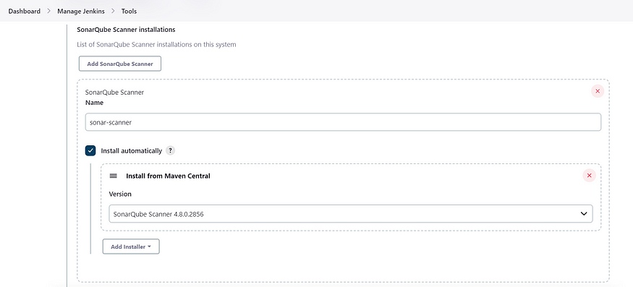
Lets goto our Pipeline and add Sonar-qube Stage in our Pipeline Script
pipeline {
agent any
tools{
jdk 'jdk17'
maven 'maven3'
}
environment {
SCANNER_HOME=tool 'sonar-scanner'
}
stages{
stage("Git Checkout"){
steps{
git branch: 'main', changelog: false, poll: false, url: 'https://github.com/Milky19/Petclinic.git'
}
}
stage("Compile"){
steps{
sh "mvn clean compile"
}
}
stage("Test Cases"){
steps{
sh "mvn test"
}
}
stage("Sonarqube Analysis "){
steps{
withSonarQubeEnv('sonar-server') {
sh ''' $SCANNER_HOME/bin/sonar-scanner -Dsonar.projectName=Petclinic \
-Dsonar.java.binaries=. \
-Dsonar.projectKey=Petclinic '''
}
}
}
stage("quality gate"){
steps {
script {
waitForQualityGate abortPipeline: false, credentialsId: 'Sonar-token'
}
}
}
stage ('sonarqube Analysis'){
steps{
script{
withSonarQubeEnv(credentialsId: 'Sonar-token') {
sh 'mvn sonar:sonar'
}
}
}
}
}
}
Click on Build now, you will see the stage view like this
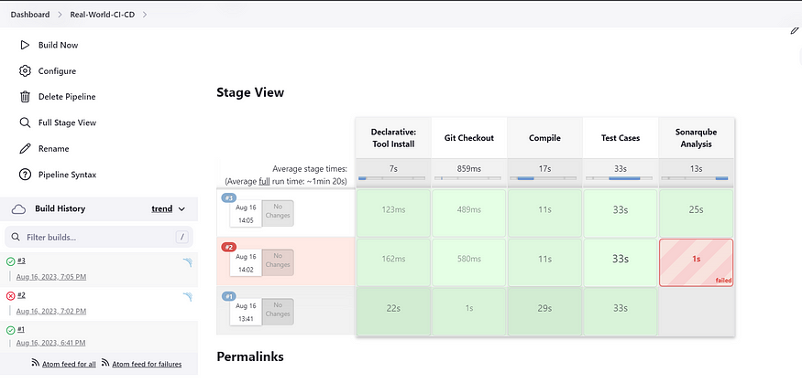
To see the report, you can goto Sonarqube Server and goto Projects.
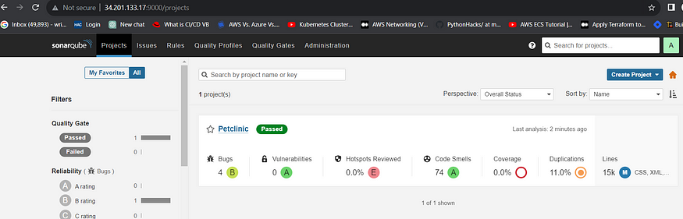
You can see the report has been generated and the status shows as passed. You can see that there are 15K lines. To see detailed report, you can go to issues.
Step 5 — Install OWASP Dependency Check Plugins
GotoDashboard → Manage Jenkins → Plugins → OWASP Dependency-Check. Click on it and install without restart.
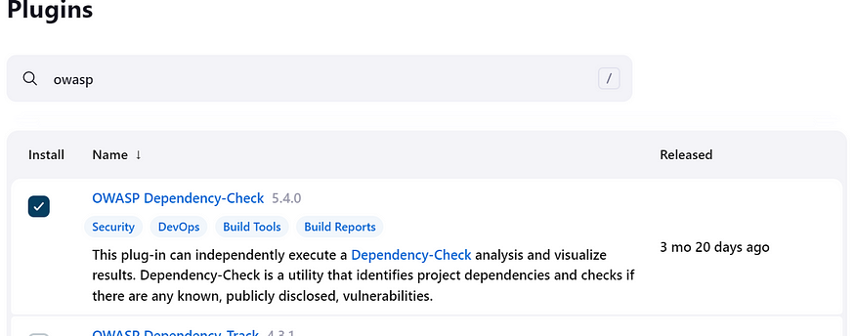
First, we configured Plugin and next we have to configure Tool
Goto Dashboard → Manage Jenkins → Tools →
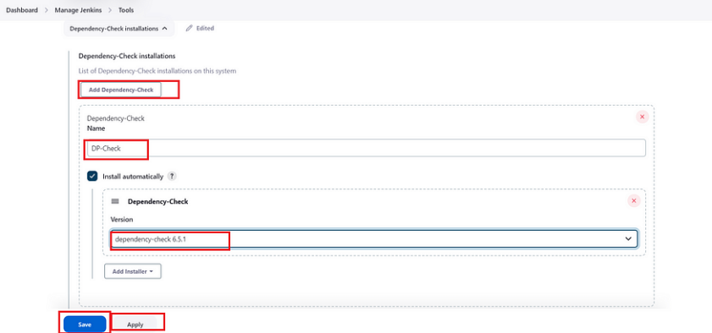
Click on apply and Save here.
Now goto configure → Pipeline and add this stage to your pipeline
stage("OWASP Dependency Check"){
steps{
dependencyCheck additionalArguments: '--scan ./ --format HTML ', odcInstallation: 'DP-Check'
dependencyCheckPublisher pattern: '**/dependency-check-report.html'
}
}
stage("Build"){
steps{
sh " mvn clean install"
}
}
The final pipeline would look like this,
pipeline {
agent any
tools{
jdk 'jdk17'
maven 'maven3'
}
environment {
SCANNER_HOME=tool 'sonar-scanner'
}
stages{
stage("Git Checkout"){
steps{
git branch: 'main', changelog: false, poll: false, url: 'https://github.com/Milky19/Petclinic.git'
}
}
stage("Compile"){
steps{
sh "mvn clean compile"
}
}
stage("Test Cases"){
steps{
sh "mvn test"
}
}
stage("Sonarqube Analysis "){
steps{
withSonarQubeEnv('sonar-server') {
sh ''' $SCANNER_HOME/bin/sonar-scanner -Dsonar.projectName=Petclinic \
-Dsonar.java.binaries=. \
-Dsonar.projectKey=Petclinic '''
}
}
}
stage("Build"){
steps{
sh " mvn clean install"
}
}
stage("OWASP Dependency Check"){
steps{
dependencyCheck additionalArguments: '--scan ./ --format HTML ' , odcInstallation: 'DP-Check'
dependencyCheckPublisher pattern: '**/dependency-check-report.html'
}
}
}
}
The stage view would look like this,
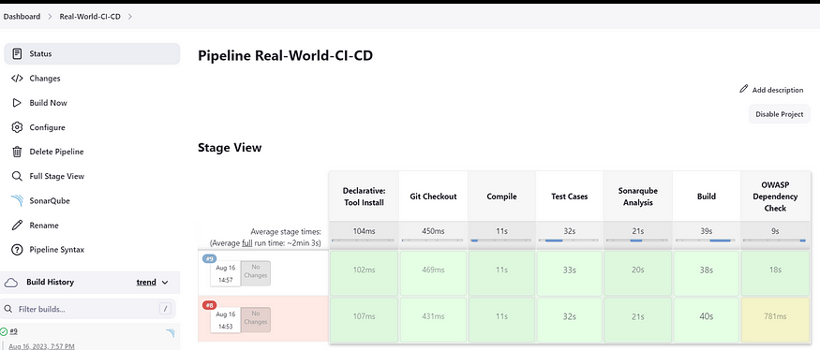
You will see that in status, a graph will also be generated
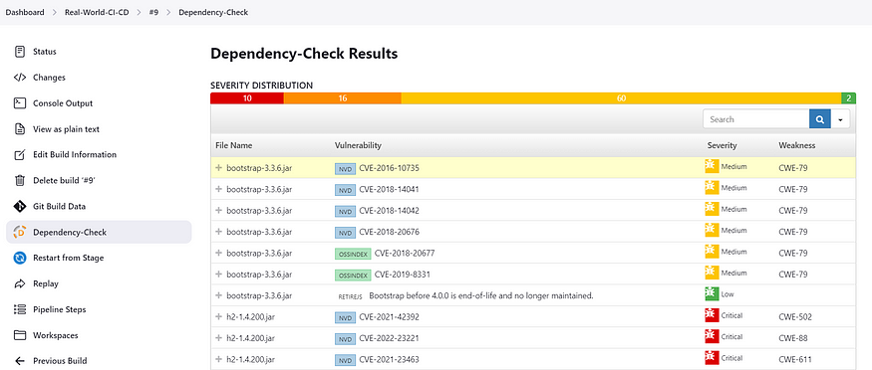
Step 6 — Docker Image Build and Push
We need to install Docker tool in our system, Goto Dashboard → Manage Plugins → Available plugins → Search for Docker and install these plugins
- Docker
- Docker Commons
- Docker Pipeline
- Docker API
- docker-build-step
and click on install without restart
Now, goto Dashboard → Manage Jenkins → Tools →
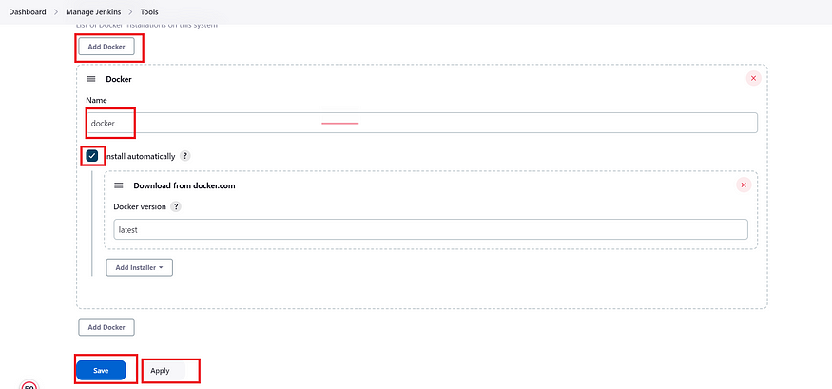
Add DockerHub Username and Password under Global Credentials
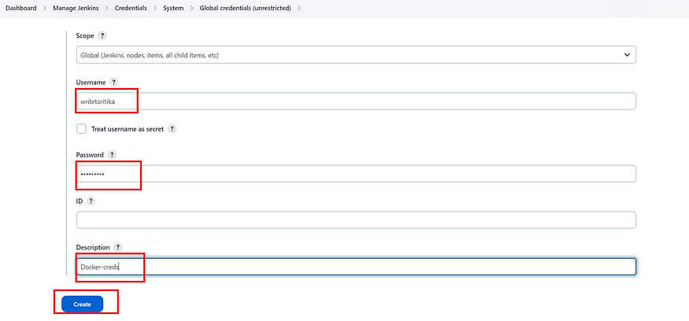
Add this stage in Pipeline Script
stage("Docker Build & Push"){
steps{
script{
withDockerRegistry(credentialsId: ‘docker', toolName: 'docker') {
sh "docker build -t petclinic1 ."
sh "docker tag petclinic1 Milky19/pet-clinic123:latest "
sh "docker push Milky19/pet-clinic123:latest "
}
}
}
}
You will see the output like below,
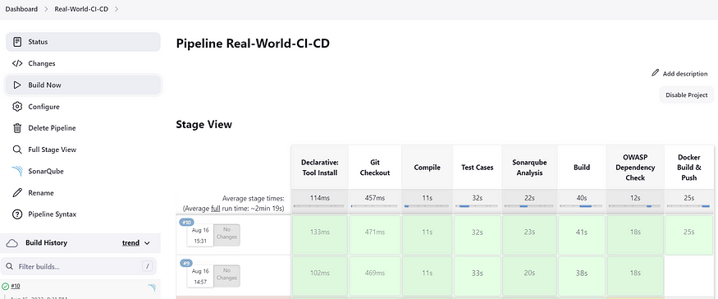
Now, when you do
docker images
You will see this output
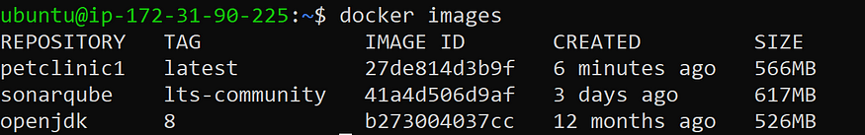
When you log in to Dockerhub, you will see a new image is created
Step 7 — Deploy image using Docker
Add this stage to your pipeline syntax
stage("Deploy Using Docker"){
steps{
sh " docker run -d --name pet1 -p 8082:8082 hanvitha/pet-clinic123:latest "
}
}
You will see the Stage View like this,
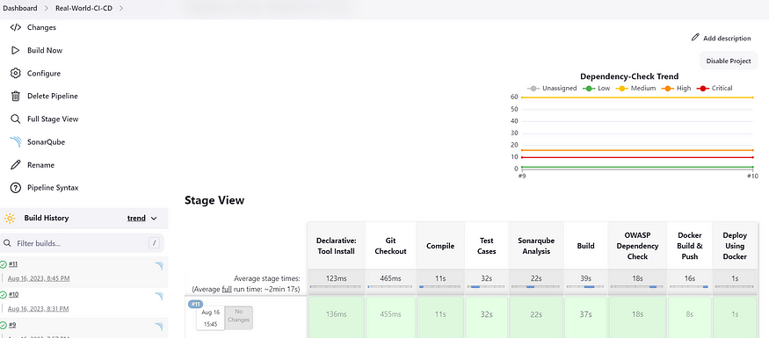
Step 8 — Install Tomcat on Port 8083 and finally deploy on Apache Tomcat using groovy pipeline script mentioned
Before we add Pipeline Script, we need to install and configure Tomcat on our server.
Here are the steps to install Tomcat 9
  - ##################----INSTALL TOMCAT----##################
Commands are in Yellow color
  - --> change to opt directory
  - cd /opt
  - --> Download tomcat file using wget command
  - sudo wget https://archive.apache.org/dist/tomcat/tomcat-9/v9.0.65/bin/apache-tomcat-9.0.65.tar.gz
  - sudo wget https://dlcdn.apache.org/tomcat/tomcat-9/v9.0.80/bin/apache-tomcat-9.0.80.tar.gz (Another link )

  - --> Unzip tar file
  - sudo tar -xvf apache-tomcat-9.0.65.tar.gz

  - --> move to conf directory and change port in tomcat server to another port from default port
  - cd /opt/apache-tomcat-9.0.65/conf
  - vi server.xml
  - --> update tomcat users xml file for manager app login.
  - cd /opt/apache-tomcat-9.0.65/conf
  - sudo vi tomcat-users.xml
  - # ---add-below-line at the end (2nd-last line)----
  - <user username="admin" password="admin1234" roles="admin-gui, manager-gui"/>

  - --> create a symbolic links for direct start and stop of tomcat

  - sudo ln -s /opt/apache-tomcat-9.0.65/bin/startup.sh /usr/bin/startTomcat
  - sudo ln -s /opt/apache-tomcat-9.0.65/bin/shutdown.sh /usr/bin/stopTomcat

  - sudo vi /opt/apache-tomcat-9.0.65/webapps/manager/META-INF/context.xml

  - comment:
  - <!-- Valve className="org.apache.catalina.valves.RemoteAddrValve"
  - allow="127\.\d+\.\d+\.\d+|::1|0:0:0:0:0:0:0:1" /> -->

  - sudo vi /opt/apache-tomcat-9.0.65/webapps/host-manager/META-INF/context.xml

  - comment:
  - <!-- Valve className="org.apache.catalina.valves.RemoteAddrValve"
  - allow="127\.\d+\.\d+\.\d+|::1|0:0:0:0:0:0:0:1" /> -->

  - sudo stopTomcat
  - sudo startTomcat
  - Certainly! To allow both the ubuntu and jenkins users to copy the petclinic.war file to the /opt/apache-tomcat-9.0.65/webapps/ directory without entering passwords, you can add the appropriate entries to the /etc/sudoers file. Here's how you can do it:
  - Open a terminal.
  - Use the sudo command to edit the sudoers file using a text editor like visudo:
  - sudo visudo
  - Scroll down to an appropriate section (e.g., just below the line with %sudo ALL=(ALL:ALL) ALL) and add the following lines:
  - ubuntu ALL=(ALL) NOPASSWD: /bin/cp /var/lib/jenkins/workspace/petclinic/target/petclinic.war /opt/apache-tomcat-9.0.65/webapps/ jenkins ALL=(ALL) NOPASSWD: /bin/cp /var/lib/jenkins/workspace/petclinic/target/petclinic.war /opt/apache-tomcat-9.0.65/webapps/
  - Save the file and exit the text editor.
  - By adding these lines, you're allowing both the ubuntu user and the jenkins user to run the specified cp command without being prompted for a password.
  - After making these changes, both users should be able to run the Jenkins job that copies the petclinic.war file to the specified directory without encountering permission issues. Always ensure that you're cautious when editing the sudoers file and that you verify the paths and syntax before saving any changes.
SincePort 8080 is being used by Jenkins, we have used Port 8083 to host Tomcat Server
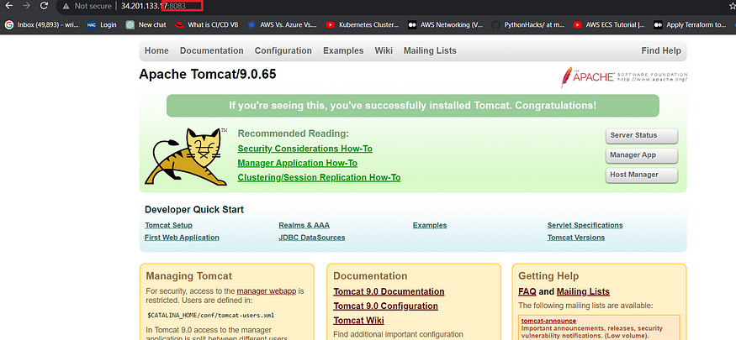
Add this stage to your Pipeline script
stage("Deploy To Tomcat"){
steps{
sh "cp /var/lib/jenkins/workspace/Real-World-CI-CD/target/petclinic.war /opt/apache-tomcat-9.0.65/webapps/ "
}
}
Kindly note that this application can be deployed via Docker and also via Tomcat Server.
pipeline {
agent any
tools{
jdk 'jdk17'
maven 'maven3'
}
environment {
SCANNER_HOME=tool 'sonar-scanner'
}
stages{
stage("Git Checkout"){
steps{
git branch: 'main', changelog: false, poll: false, url: 'https://github.com/Milky19/Petclinic.git'
}
}
stage("Compile"){
steps{
sh "mvn clean compile"
}
}
stage("Test Cases"){
steps{
sh "mvn test"
}
}
stage("Build"){
steps{
sh " mvn clean install"
}
}
stage("OWASP Dependency Check"){
steps{
dependencyCheck additionalArguments: '--scan ./ --format HTML ' , odcInstallation: 'DP-Check'
dependencyCheckPublisher pattern: '**/dependency-check-report.html'
}
}
stage("Docker Build & Push"){
steps{
script{
withDockerRegistry(credentialsId: 'docker’, toolName: 'docker') {
sh "docker build -t petclinic1 ."
sh "docker tag petclinic1 hanvitha/pet-clinic123:latest "
sh "docker push hanvitha/pet-clinic123:latest "
}
}
}
}
stage("Deploy Using Docker"){
steps{
sh " docker run -d --name pet12 -p 8082:8082 hanvitha/pet-clinic123:latest "
}
}
stage("Deploy To Tomcat"){
steps{
sh "cp target/petclinic.war /opt/apache-tomcat-9.0.65/webapps/ "
}
}
}
}
And you can access your application on Port 8083. This is a Real World Application that has all Functional Tabs.
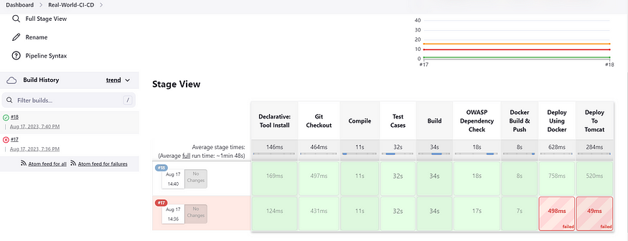
Step 9: Access the Real World Application
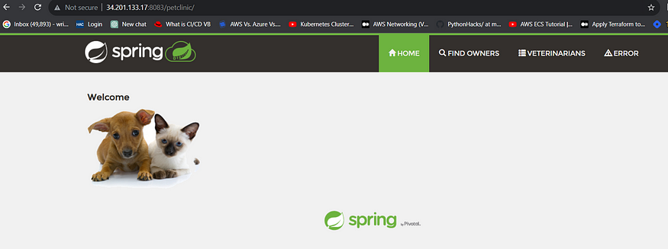
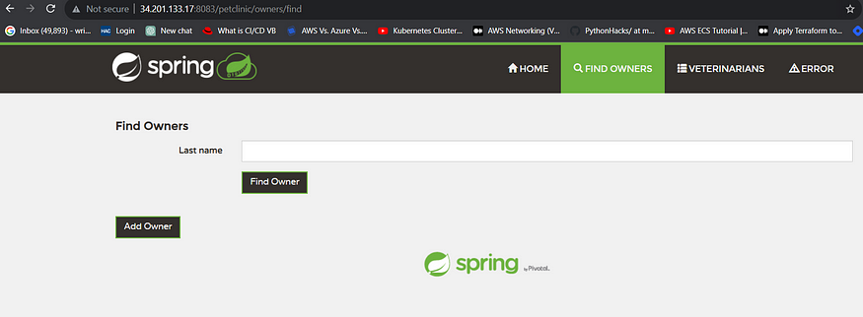
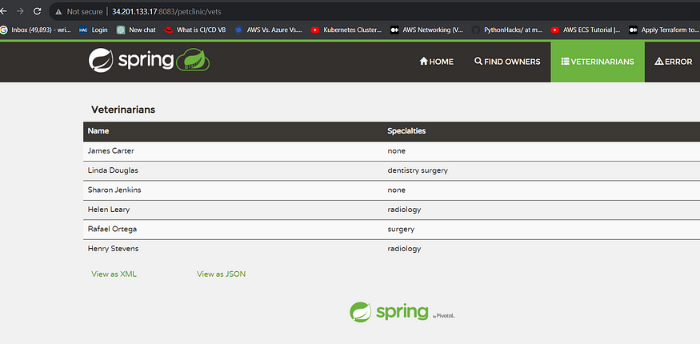

STEP: 10 Take Two Ubuntu 20.04 instances one for k8s master and other one for worker also install on Jenkins machine (only kubectl)

Kubectl on Jenkins to be installed
sudo apt update
sudo apt install curl
curl -LO https://dl.k8s.io/release/$(curl -L -s https://dl.k8s.io/release/stable.txt)/bin/linux/amd64/kubectl
sudo install -o root -g root -m 0755 kubectl /usr/local/bin/kubectl
kubectl version –client

Part 1 ----------------------------Master ------------

sudo su
hostname master
bash
clear

Node --------------

sudo su
hostname master
bash
clear

Part 2 -----------------------------------------------------Both Master & Node -------------

sudo apt-get update && sudo apt-get upgrade -y

sudo apt-get install -y docker.io
sudo usermod –aG docker Ubuntu
newgrp docker
sudo chmod 777 /var/run/docker.sock

sudo curl -s https://packages.cloud.google.com/apt/doc/apt-key.gpg | sudo apt-key add -

sudo tee /etc/apt/sources.list.d/kubernetes.list <<EOF
deb https://apt.kubernetes.io/ kubernetes-xenial main
EOF

sudo apt-get update

sudo apt-get install -y kubelet kubeadm kubectl

snap install kube-apiserver

Part 3 ----------------------------------------------- Master ---------------

sudo kubeadm init --pod-network-cidr=10.244.0.0/16

mkdir -p $HOME/.kube
sudo cp -i /etc/kubernetes/admin.conf $HOME/.kube/config
sudo chown $(id -u):$(id -g) $HOME/.kube/config

kubectl apply -f https://raw.githubusercontent.com/coreos/flannel/master/Documentation/kube-flannel.yml

Node ----------

paster the kube adm join command which is in this format: sudo kubeadm join <master-node-ip>:<master-node-port> --token <token> --discovery-token-ca-cert-hash <hash>

Part 4 ----------------------------------------------------------------
Master -----------------

kubectl get nodes
---------------------------------------------------------------------------------------------------------------
CONGRATULATIONS FOR YOUR NEW KUBERNETES CLUSTER ON UBUNTU ON EC2

Copy config file to Jenkins master or to local file manager and save it
Install Kubernetes plugins

Install Kubernetes Plugin, once its installed successfully. goto manage jenkins --> manage credentials --> Click on jenkins global --> add credentials

Configuring mail server in Jenkins ( Gmail )

Install Email Extension Plugin in Jenkins
Once plugin installed in jenkins, click on manage jenkins --> configure system there under E-mail Notification section configure the details as shown in below image

this is to just verify mail configuration
Now under Extended E-mail Notification section configure the details as shown in below images
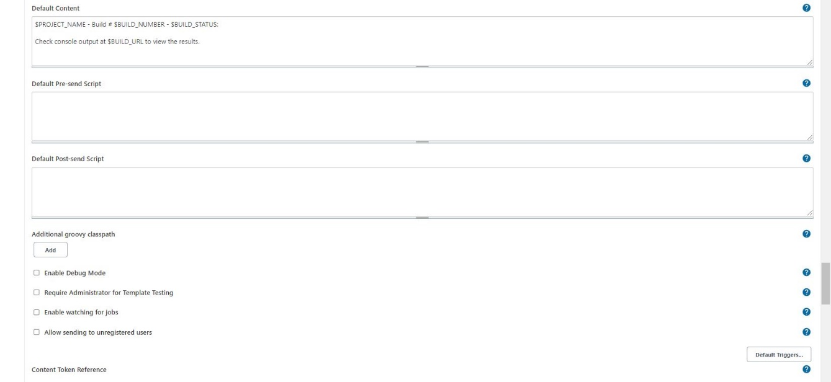
By using below code i can send customized mail
post {
always {
mail bcc: '', body: "<br>Project: ${env.JOB_NAME} <br>Build Number: ${env.BUILD_NUMBER} <br> URL de build: ${env.BUILD_URL}", cc: '', charset: 'UTF-8', from: '', mimeType: 'text/html', replyTo: '', subject: "${currentBuild.result} CI: Project name -> ${env.JOB_NAME}", to: "krishna04.b@gmail.com";
}
}
also which ever the mail you use for authentication in that mail setting "Less secure apps access" should be enabled

Step 11: Terminate the AWS EC2 Instance
Total script:
pipeline{
agent any
tools{
jdk 'jdk17'
maven 'maven3'
}
environment {
SCANNER_HOME=tool 'sonar-scanner'
}
stages {
stage('clean workspace'){
steps{
cleanWs()
}
}
stage('Checkout From Git'){
steps{
git branch: 'main', url: 'https://github.com/Milky19/Petclinic-Real.git'
}
}
stage('mvn compile'){
steps{
sh 'mvn clean compile'
}
}
stage('mvn test'){
steps{
sh 'mvn test'
}
}
stage("Sonarqube Analysis "){
steps{
withSonarQubeEnv('sonar-server') {
sh ''' $SCANNER_HOME/bin/sonar-scanner -Dsonar.projectName=Petclinic \
-Dsonar.java.binaries=. \
-Dsonar.projectKey=Petclinic '''
}
}
}
stage("quality gate"){
steps {
script {
waitForQualityGate abortPipeline: false, credentialsId: 'Sonar-token'
}
}
}
stage('mvn build'){
steps{
sh 'mvn clean install'
}
}
stage("OWASP Dependency Check"){
steps{
dependencyCheck additionalArguments: '--scan ./ --format HTML ', odcInstallation: 'DP-Check'
dependencyCheckPublisher pattern: '**/dependency-check-report.html'
}
}
stage("Docker Build & Push"){
steps{
script{
withDockerRegistry(credentialsId: 'docker', toolName: 'docker'){
sh "docker build -t petclinic1 ."
sh "docker tag petclinic1 hanvitha/petclinic1:latest "
sh "docker push hanvitha/petclinic1:latest "
}
}
}
}
stage("TRIVY"){
steps{
sh "trivy image hanvitha/petclinic1:latest> trivy.txt"
}
}
stage('Clean up containers') { //if container runs it will stop and remove this block
steps {
script {
try {
sh 'docker stop pet1'
sh 'docker rm pet1'
} catch (Exception e) {
echo "Container pet1 not found, moving to next stage"
}
}
}
}
stage ('Manual Approval'){
steps {
script {
timeout(time: 10, unit: 'MINUTES') {
def approvalMailContent ="""
Project: ${env.JOB_NAME}
Build Number: ${env.BUILD_NUMBER}
Go to build URL and approve the deployment request.
URL de build: ${env.BUILD_URL}
"""
mail(
to: 'krishna04.b@gmail.com',
subject: "${currentBuild.result} CI: Project name ->${env.JOB_NAME}",
body: approvalMailContent,
mimeType: 'text/plain'
)
input(
id: "DeployGate",
message: "Deploy ${params.project_name}?",
submitter: "approver",
parameters: [choice(name: 'action', choices: ['Deploy'], description: 'Approve deployment')]
)
}
}
}
}
stage('Deploy to conatiner'){
steps{
sh 'docker run -d --name pet1 -p 8082:8080 hanvitha/petclinic1:latest'
}
}
stage("Deploy To Tomcat"){
steps{
sh "sudo cp /var/lib/jenkins/workspace/petclinic/target/petclinic.war /opt/apache-tomcat-9.0.65/webapps/ "
}
}
stage('Deploy to kubernets'){
steps{
script{
withKubeConfig(caCertificate: '', clusterName: '', contextName: '', credentialsId: 'k8s', namespace: '', restrictKubeConfigAccess: false, serverUrl: '') {
sh 'kubectl apply -f deployment.yaml'
}
}
}
}
}
post {
always {
emailext attachLog: true,
subject: "'${currentBuild.result}'",
body: "Project: ${env.JOB_NAME}<br/>"+
"Build Number: ${env.BUILD_NUMBER}<br/>"+
"URL: ${env.BUILD_URL}<br/>",
to: 'hanvitha@gmail.com',
attachmentsPattern: 'trivy.txt'
}
}
}

// try this approval stage also

stage('Manual Approval') {
timeout(time: 10, unit: 'MINUTES') {
mail to: 'krishna04.b@gmail.com',
subject: "${currentBuild.result} CI: ${env.JOB_NAME}",
body: "Project: ${env.JOB_NAME}\nBuild Number: ${env.BUILD_NUMBER}\nGo to ${env.BUILD_URL} and approve deployment"
input message: "Deploy ${params.project_name}?",
id: "DeployGate",
submitter: "approver",
parameters: [choice(name: 'action', choices: ['Deploy'], description: 'Approve deployment')]
}
}

